- Online Health Checklist

Entry:
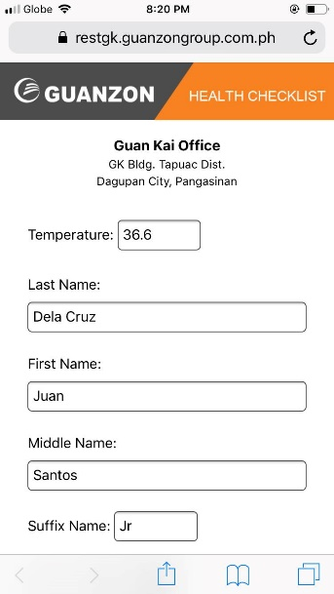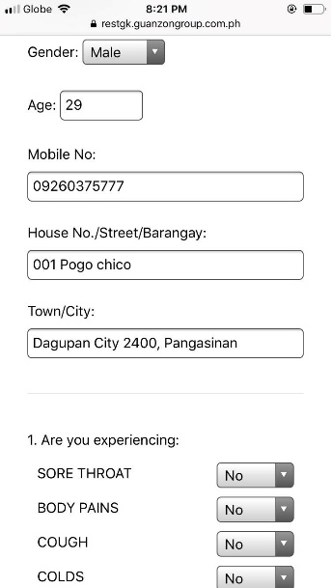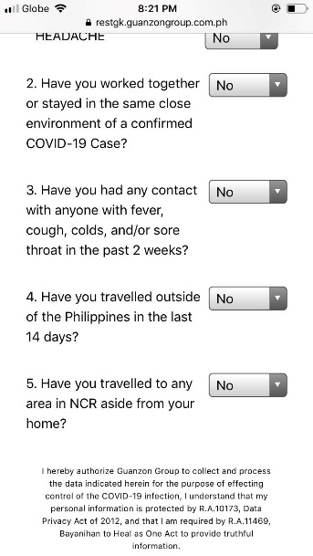
Confirmation:
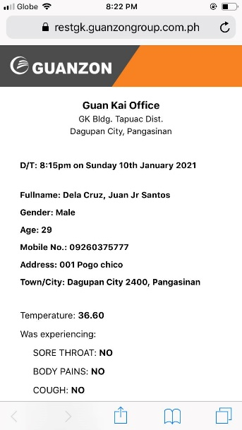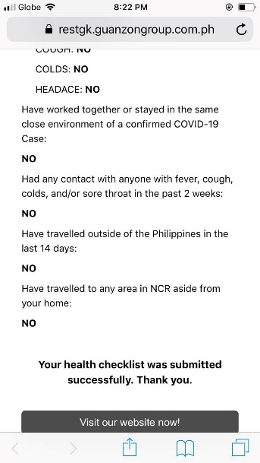

The health checklist form was translated to an online version. Wherein our clients can now submit their health checklist using their mobile phone. On the implementation of this app, every branch will have a QR Code which contains the link for the online health checklist. They have to scan the code to redirect on the page where they can fill up the checklist. The screenshots above is a sample entry and a confirmation upon submission.

- Allocate Inventory for SP Customer Order
- CarTrade Credit Application
- General Journal

